FARM MANAGEMENT SYSTEM
A Project report submitted In partial
fulfillment Of The requirements for the course
Submitted by:
A. SABREEN [23131061805222011]
J. HARINI [23131061805222007]
A. BAVYA [23131061805222006]
A. SHEEBA [23131061805222013]
Department of Data Science
SHREE RAGHAVENDRA ARTS AND SCIENCE COLLEGE
KEEZHAMOONGILADI, CHIDAMBARAM-608 102

FARM MANAGEMENT SYSTEM

USER STORY
In the Farm Management System (FMS), farmers, farm supervisors, and administrators use a centralized digital platform to manage agricultural data efficiently. The system allows users to record information related to farms, crops, farmers, and buyers in an organized database. Farmers can update crop production details, managers can monitor farm performance, and buyers can access crop availability information. The system ensures data accuracy through validation and secure access controls. With the help of reports and dashboards, users can analyze production and sales data to support better decision-making.
This system reduces manual paperwork, improves operational efficiency, and helps modernize agricultural management through technology.

1. INTRODUCTION

1.1 Project Overview
The Farm Management System is a cloud-based application developed using the Salesforce platform. The system helps manage agricultural activities digitally by storing information related to farms, crops, farmers, and buyers in one centralized system.
Through this platform, users can easily record farming activities, track crop production, and monitor business transactions. The system also provides analytical reports and dashboards to help farm managers make informed decisions about productivity and operations.

1.2 Purpose
The main goals of the Farm Management System are:
Convert manual farm records into digital data
Improve accessibility and organization of agricultural information
Reduce errors in data recording
Enable faster reporting and monitoring
Improve farm productivity through data analysis
Increase transparency in farm operations

2. IDEATION PHASE

2.1 Problem Statement
Many farms still rely on traditional record-keeping methods such as paper registers or spreadsheets. These methods often lead to problems such as lost data, inaccurate records, and delayed reporting.
Farmers find it difficult to manage crop details and track productivity efficiently. Farm managers struggle to monitor performance due to scattered information sources. Buyers also face difficulty accessing updated information about crop availability. Therefore, there is a need for a centralized digital platform that simplifies farm data management and improves communication between stakeholders.
2.2 Empathy Map Canvas

Target Users
Farmers
Farm Managers
Buyers
System Administrators

Empathy Analysis
Think & Feel
Need reliable and updated agricultural information
Want simple tools to manage farm operations
Hear
Advice from agricultural officers
Feedback from buyers and market agents
See
Paper records
Spreadsheets and manual registers
Say & Do
Enter crop information manually
Maintain multiple files for records
Pain
Data loss
Inconsistent information
Time-consuming reporting
Gain
Automated record management
Accurate reports Faster decision making

2.3 Brainstorming
Several ideas were considered during the brainstorming stage:
Manual record tracking system
Spreadsheet-based farm management
Web-based farm management platform
Mobile farming application
Salesforce-based farm management system

Selected Idea:
A Salesforce-based Farm Management System was selected because it provides cloud storage, automation capabilities, and powerful analytics tools. Several ideas were considered during the brainstorming stage:
Manual record tracking system
Spreadsheet-based farm management
Web-based farm management platform
Mobile farming application
Salesforce-based farm management system
3. REQUIREMENT ANALYSIS PHASE

3.1 Customer Journey Map
The typical workflow of a user in the system includes:
- User logs into the system
- Accesses the Farm Management application
- Enters or updates farm information
- Records crop production data
- Registers farmers and buyers
- Generates reports
- Analyzes data using dashboards
- Makes business decisions based on insights

3.2 Solution Requirements Functional Requirements
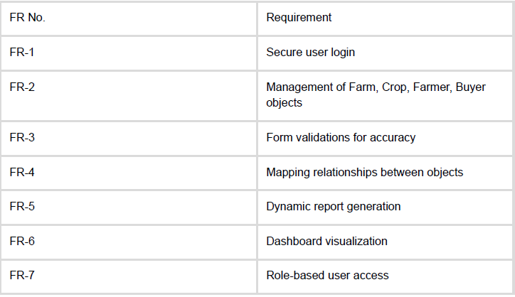

3.3 Non-Functional Requirements
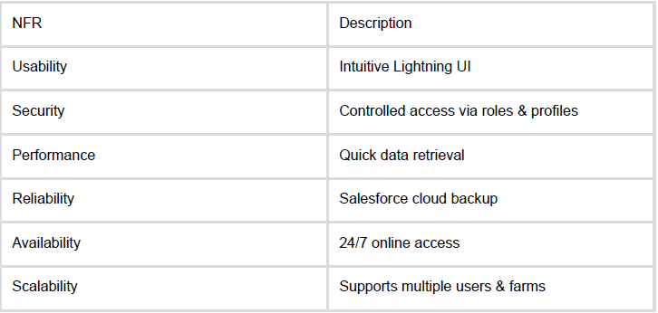

4. SYSTEM DESIGN

4.1 Problem–Solution Fit
The application resolves issues of:
Manual record loss
Slow reporting
Unorganized farm data By providing:
Automated, accurate digital entries
Cloud‑based secure storage
Real-time dashboards and reports

4.2 Proposed Solution
A Salesforce CRM-based system with:
Field validation to prevent wrong entries
Relationship configurations between crops, farms, farmers, and buyers
Automated calculations (e.g., yield estimates)
Custom dashboards for performance monitoring

4.3 Architecture Layers
- Presentation Layer – Lightning UI
- Application Layer – Rules, automation, relationships
- Data Layer – Custom objects (Farm, Crop, Farmer, Buyer)
- Analytics Layer – Reports & Dashboards

5. PROJECT PLANNING & EXECUTION

5.1 Development Plan
Activities included:
Salesforce org setup
Object creation
Fields & relationships design
App & tab configuration
User access setup
Sharing rules
Reports & dashboards creation
Testing & review
Product Backlog & Sprints
(Completely rephrased but consistent with your sample)
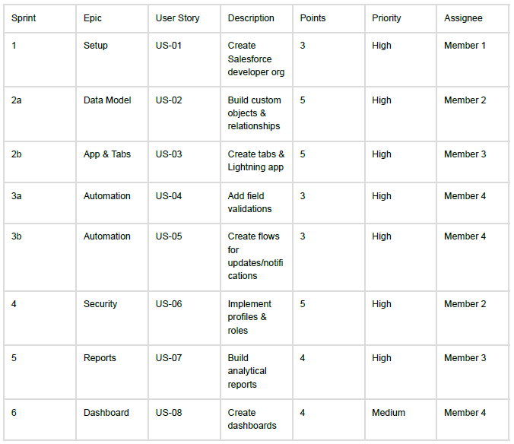

6. SYSTEM DEVELOPMENT

Milestone Highlights
- Salesforce Developer Org Setup
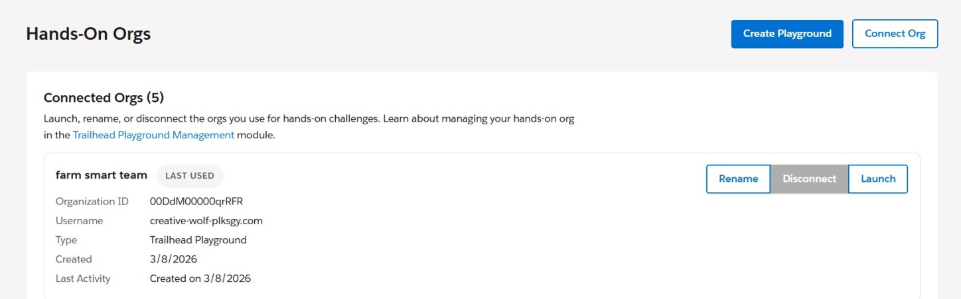
6.1. connecting the hands-on org
- Custom Object Creation
Farm
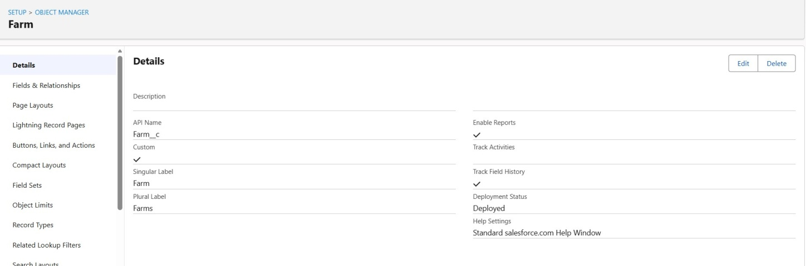
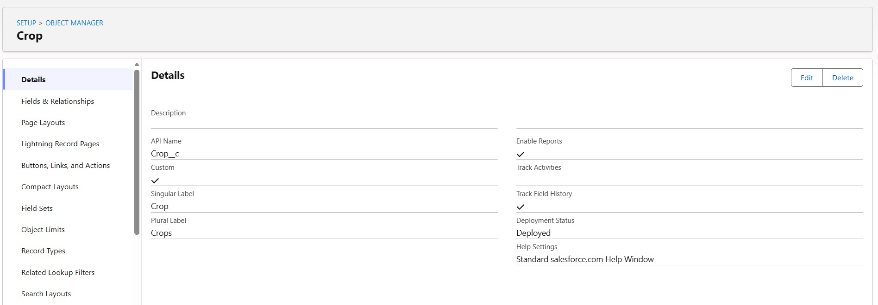
6.2
. Creating Farm Object
Crop
6.3
. Creating Crop Object
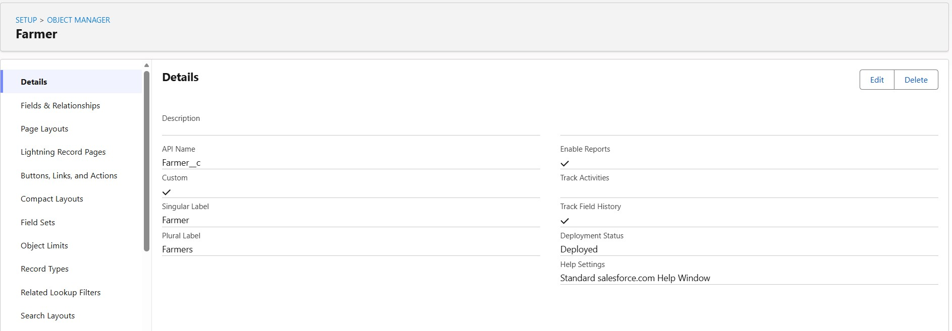
Farmer
6.4
. Creating Farmer Object
Buyer
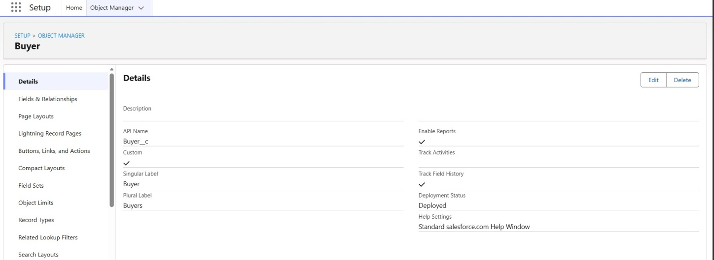
6.5. Creating Buyer Object
- Tabs & Lightning App Creation
Added navigation items
Configured app visibility
- Fields & Relationships Examples:
Farm Type (Picklist)
Irrigation Type (Picklist)
Crop Harvest Date (Date)
Buyer Contact (Phone)
Master‑Detail & Lookup relationships
Farm Fields & Relationship
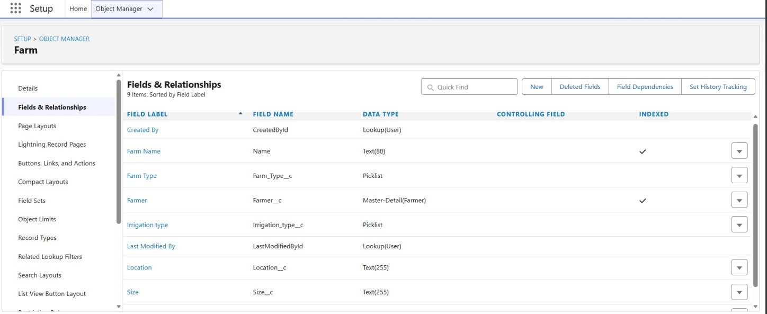
  - Farm’s Fields & Relationship
Farmer Fields & Relationship
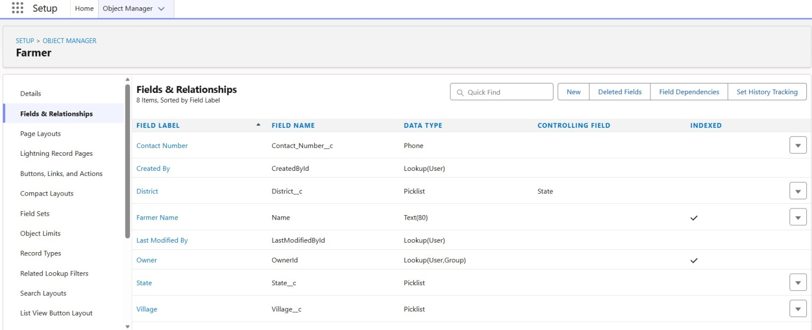
  - Farmer’s Fields & Relationship
Crop Fields & Relationship
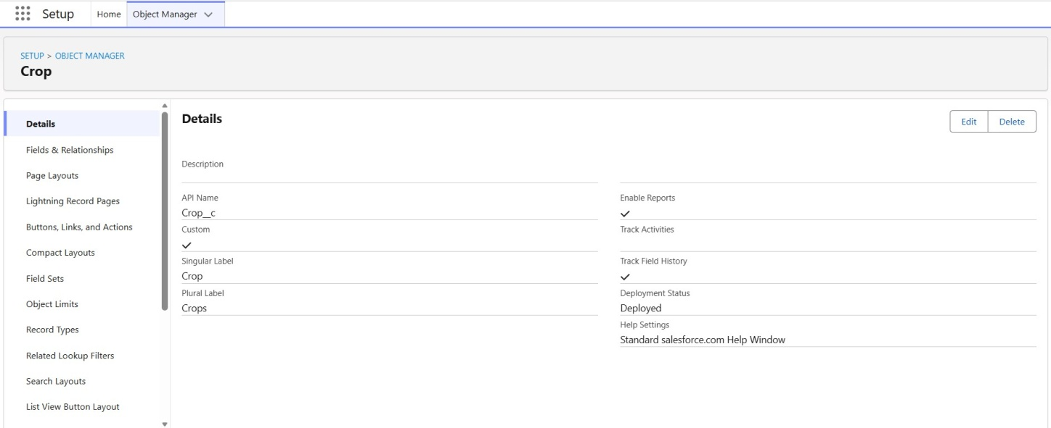
  - Crop’s Fields & RelationshipBuyer Field & Relationship

6.9 Buyer’s Field & Relationship
- Formula Fields
Example: Expected Yield = Actual yields / Totsl Harvested Acres
- Profiles & Roles
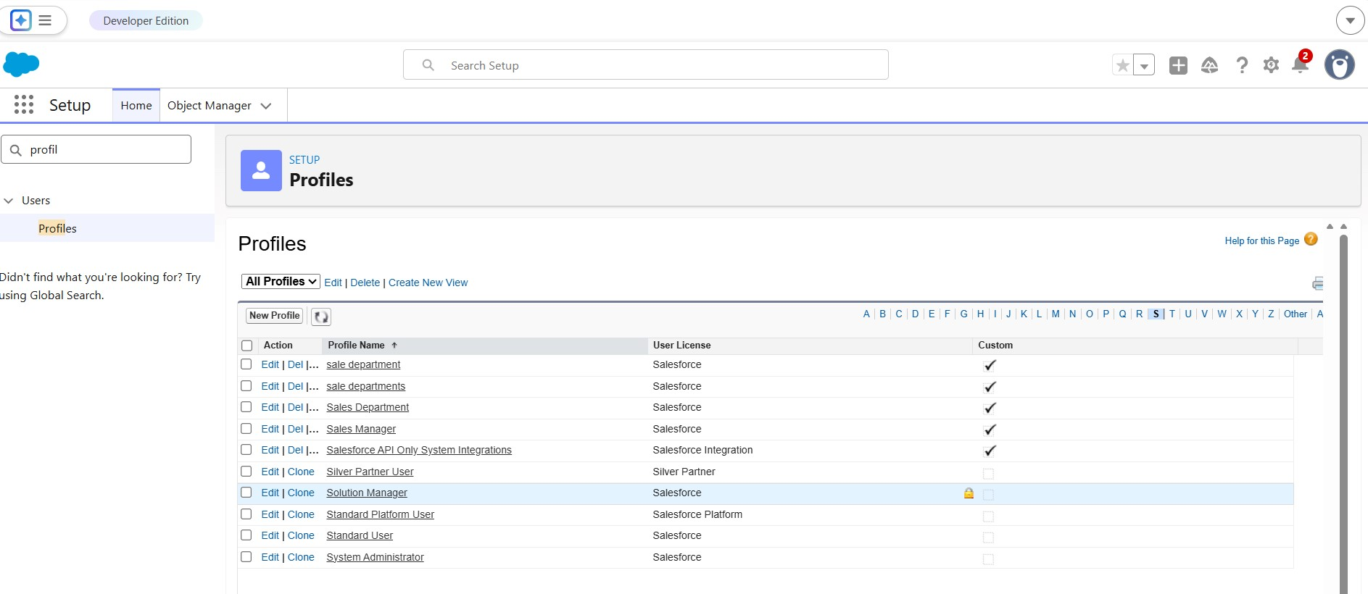
Custom profiles (Farm Manager, Sales Department)
6.10
. Profiles
Role hierarchy configuration
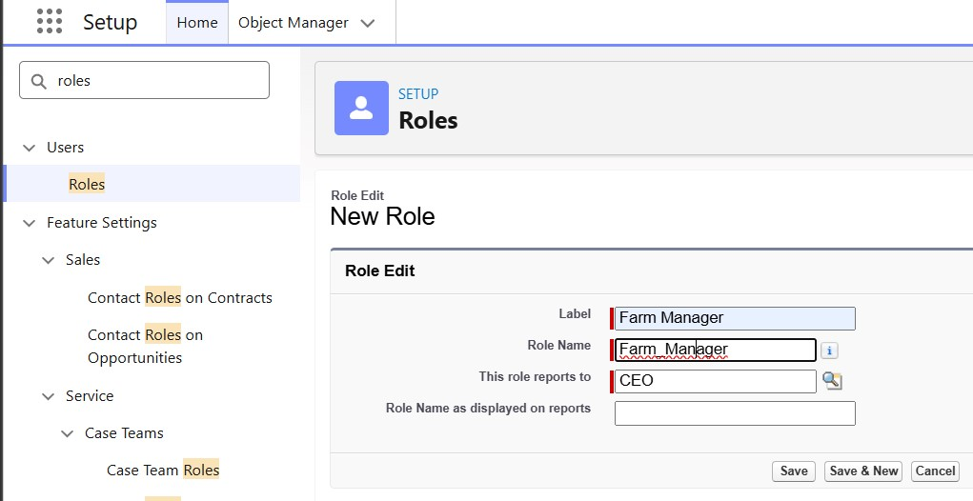
  - Farm Manager Role Creation
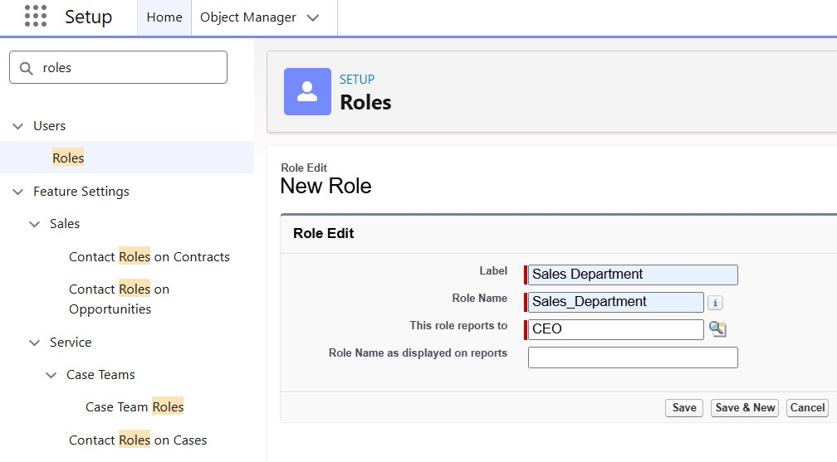
  - Sales Department Creation Role
- Farm Management System
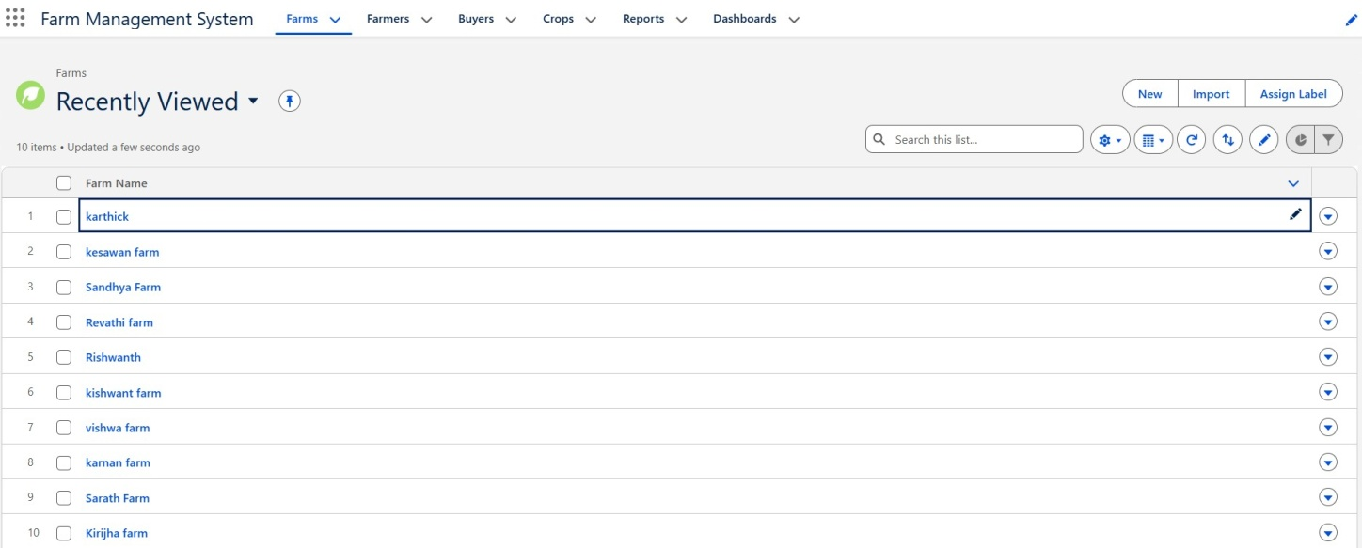
  - Farm
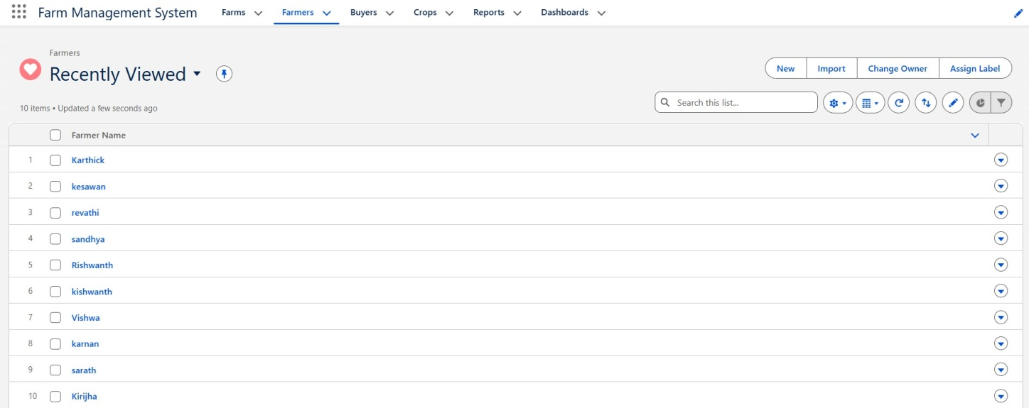
  - Farmer
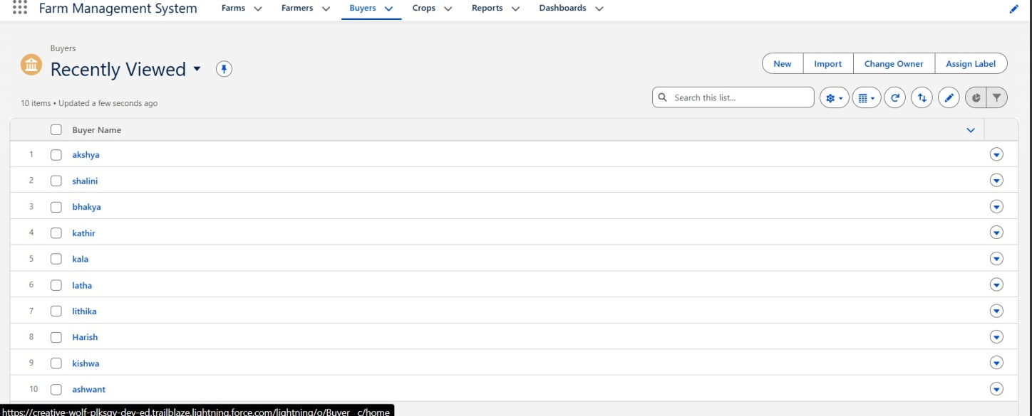

  - Buyer
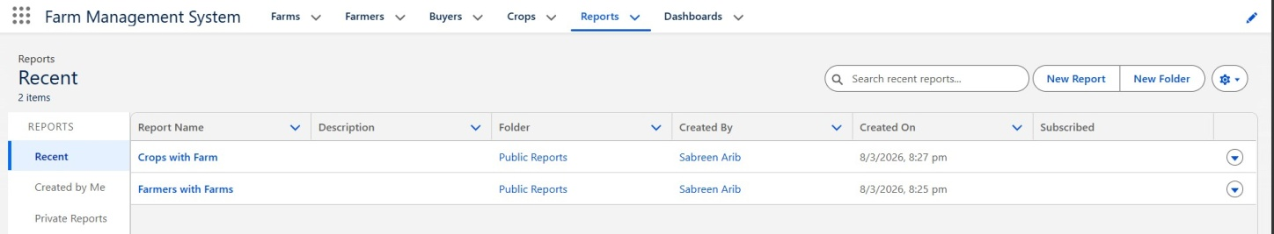

  - Reports

  - Reports Of Crop with Farms

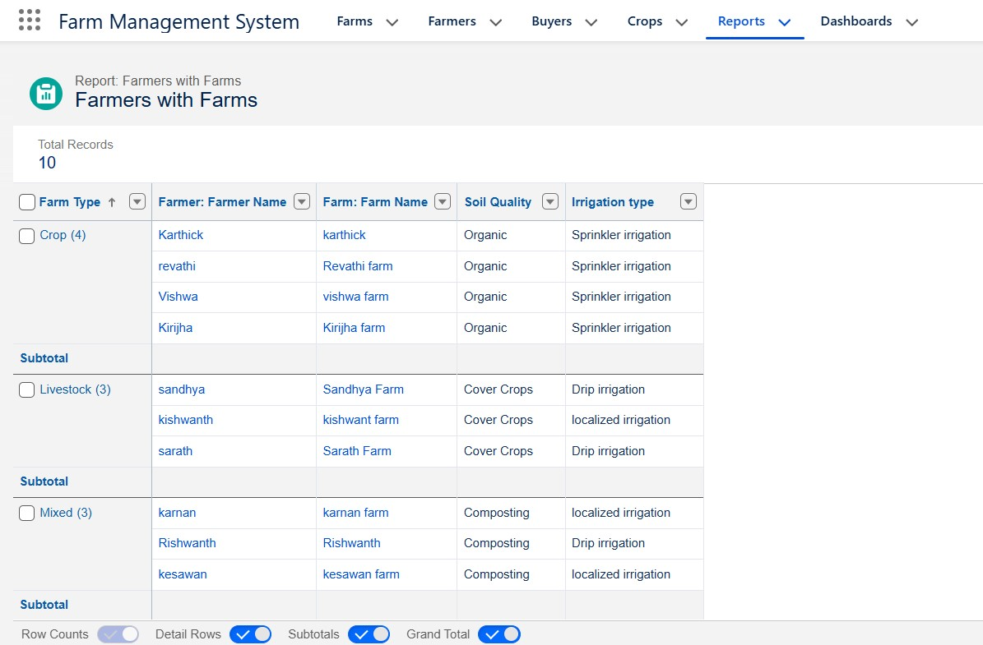
  - Reports of Farmers with Farms
- Reports & Dashboards Farm–Farmer grouped report
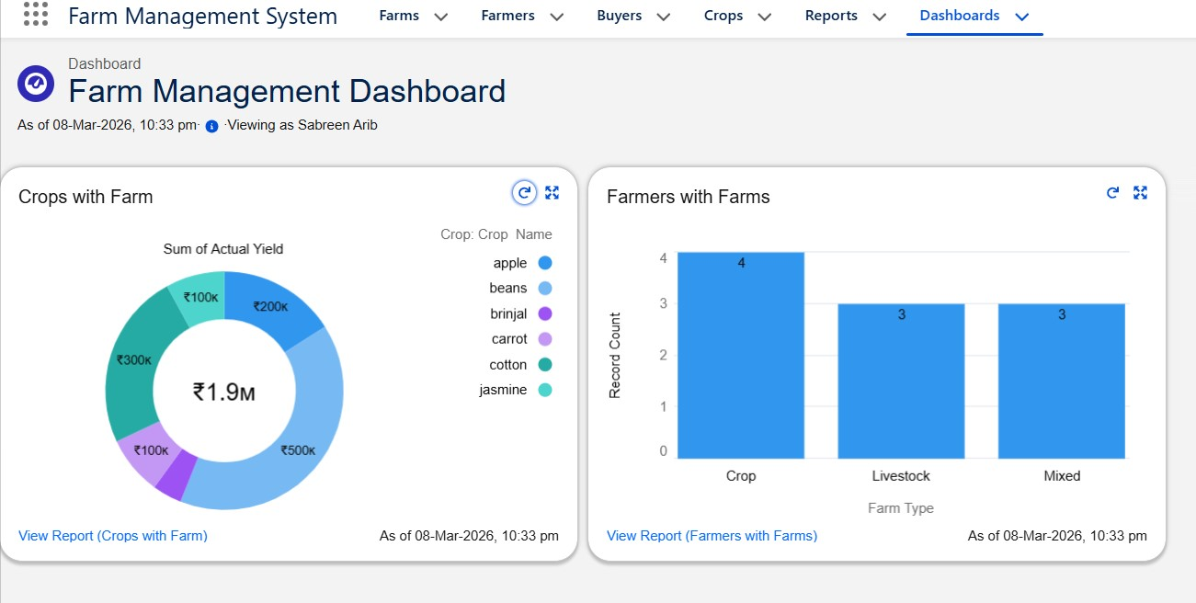
6.19. Dashboard

8. ADVANTAGES AND LIMITATIONS

Advantages
Cloud-based, secure, and scalable
Reduces manual errors
Quick insights via dashboards
Easy collaboration
Automated validation

Limitations
Requires stable internet connection
Depends on Salesforce licensing
Limited offline functionality

9. CONCLUSION
The Farm Management System transforms traditional farming records into a digital, automated ecosystem. By leveraging Salesforce’s cloud capabilities, it enhances efficiency, accuracy, and decision-making for agricultural stakeholders. The system establishes a strong foundation for future integration with emerging technologies.

10. FUTURE ENHANCEMENTS
Integration with mobile platforms
AI-based yield prediction
Weather API integrations
IoT-enabled farm monitoring
Government scheme automation
Market price forecasting tools

